SIMATS ENGINEERING
ASSESSMENT TOOL 2 : Technical Presentation

COURSE NAME: | Cloud Computing and Big Data Analytics | COURSE CODE: | CSA15

COURSE OUTCOME COVERED
CO1: Apply cloud computing technologies including hardware-software evolution, virtualization, web services, and service models to develop cloud-based solutions. (BL2)
Dave's Taxonomy: Imitation (Level 1)  Question Count: 5 | Total Marks: 50

Code of Conduct
I Nirmal Kasi 192424248 (Name / Reg No) certify that this submission is my original work and that I have adhered to the guidelines specified for this assessment.
I understand that any violation of academic integrity rules will result in disciplinary action.
Signature of the student: Nirmal

Assessment Tasks
Technical Presentation Topics
Prepare a 6-8 minute presentation on any one of the following topics. Your slides must include definitions, architecture, industry relevance, and one practical example.
Here are 10 additional technical presentation topics in a similar style, suitable for a 6–8 minute presentation with definitions, architecture, industry relevance, and a practical example:
- Containerization and Cloud-Native Applications: Transforming Modern Software Deployment
  - Explore containers, container architecture, benefits, and a real-world deployment example.
- Serverless Computing: Reducing Infrastructure Management in the Cloud
  - Discuss Function-as-a-Service (FaaS), architecture, business advantages, and practical use cases.
- Edge Computing vs Cloud Computing: Choosing the Right Computing Paradigm
  - Compare architectures, applications, and industry adoption scenarios.
- Microservices Architecture in Cloud Environments
  - Explain microservices design, benefits over monolithic systems, and industry implementations.
- Cloud Security Fundamentals: Protecting Data and Applications
  - Cover security models, shared responsibility architecture, and real-world security practices.
- Multi-Cloud and Hybrid Cloud Strategies for Enterprise IT
  - Analyze deployment models, business benefits, challenges, and practical examples.
- The Role of Artificial Intelligence and Machine Learning in Cloud Platforms
  - Discuss AI/ML cloud services, architecture, and industry applications.
- DevOps and Continuous Integration/Continuous Deployment (CI/CD) in Cloud Computing
  - Explain DevOps principles, CI/CD architecture, and practical implementation examples.
- Cloud Storage Technologies: Object, Block, and File Storage Compared
  - Compare storage architectures, use cases, and industry adoption patterns.
- Internet of Things (IoT) and Cloud Computing: Building Connected Ecosystems
  - Examine IoT-cloud architecture, benefits, challenges, and real-world applications.
- Cloud Migration Strategies: Moving Enterprise Applications to the Cloud
  - Examine migration approaches, cloud architecture considerations, benefits, challenges, and a successful migration case study.
- Big Data Analytics in Cloud Computing
  - Explore cloud-based data processing architectures, analytics platforms, business value, and real-world applications.
- Identity and Access Management (IAM) in Cloud Environments
  - Discuss authentication, authorization architectures, security benefits, and practical enterprise implementations.
- Content Delivery Networks (CDNs) and Their Role in Cloud Services
  - Explain CDN architecture, performance optimization, industry relevance, and examples from popular web platforms.
Minimum slide flow:
- Title and objective
- Core technical explanation
- Architecture or process diagram
- Real-world use case
- Conclusion and key takeaway
- Limitations and Future
- Scope

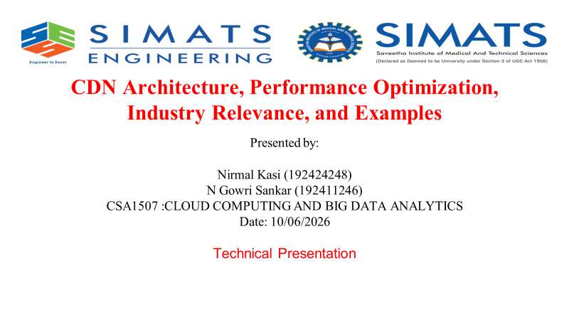
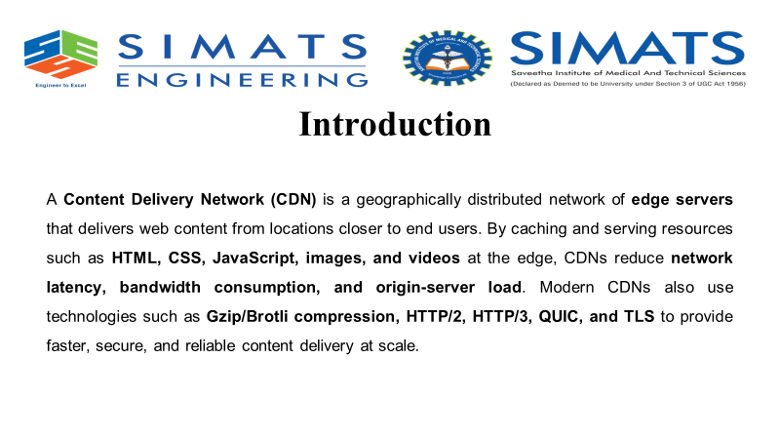
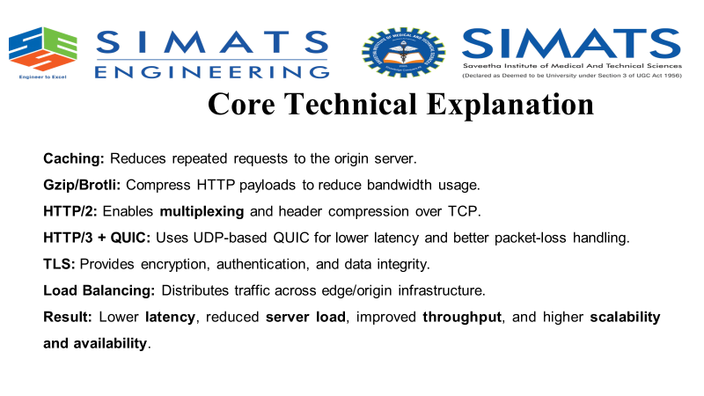
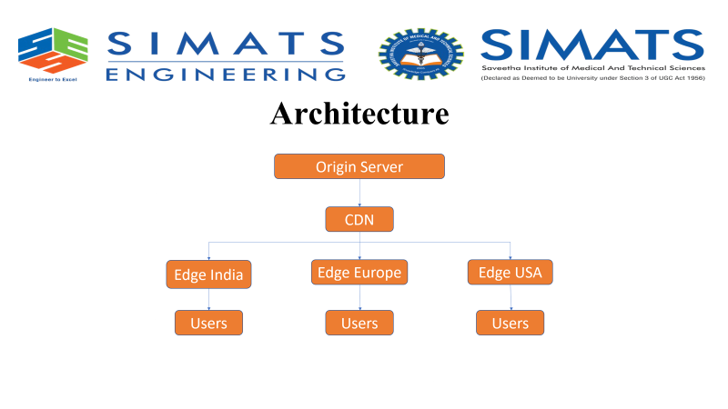
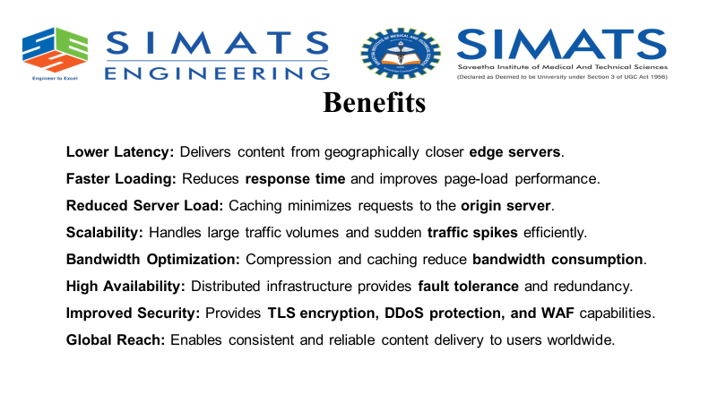
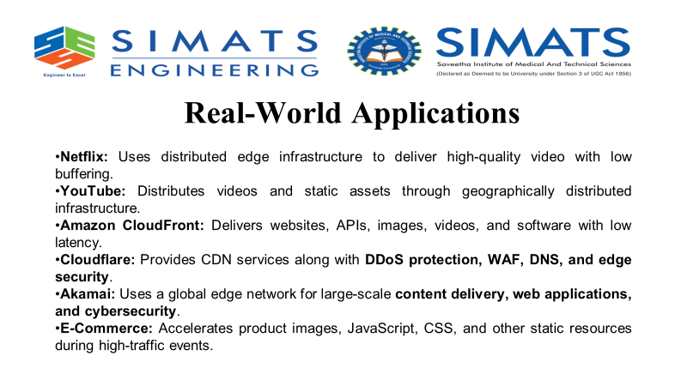
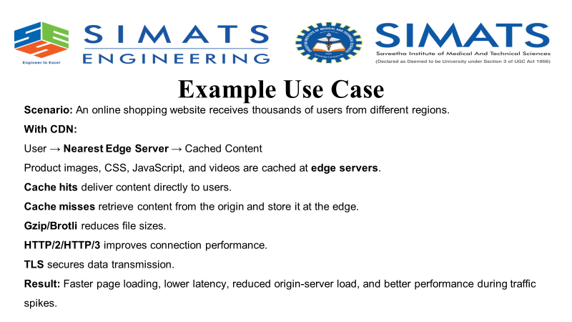
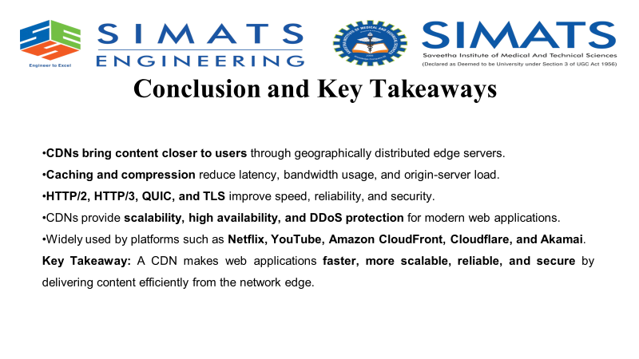
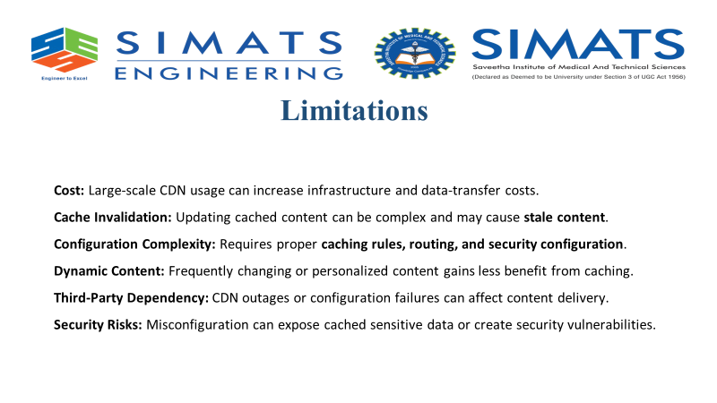

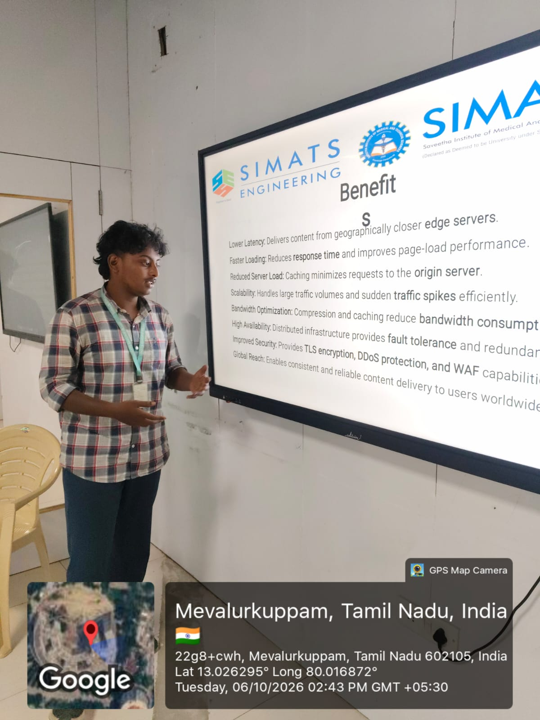

Technical Presentation Rubric

Criteria | Weightage | Level 4 - Exemplary | Level 3 - Proficient | Level 2 - Developing | Level 1 - Beginning
Technical Content | 30% | Content is highly accurate, relevant, and insightful | Content is correct with minor gaps | Basic content with limited depth | Content is inaccurate or superficial
Structure and Flow | 20% | Excellent logical flow and slide organization | Good structure with minor issues | Some organization but weak flow | Disorganized presentation
Use of Visuals | 15% | Visuals strongly support technical communication | Relevant visuals used well | Limited or unclear visuals | No meaningful visuals
Communication Skills | 20% | Confident, clear, and engaging delivery | Clear delivery with minor hesitation | Moderate clarity but uneven delivery | Weak delivery and low clarity
Professionalism | 15% | Well-prepared and audience-focused presentation | Mostly professional | Basic preparation visible | Poor preparation and professionalism

